Project Title
Battlezone Redux

Version Number: 1

Change History

Date | Author | Comments
07-02-2015 | Chris Jerrard-Dunne | Initial creation:  -Summary created.  -Assumptions and Dependencies created.
12-02-2015 | Jake Mulholland | Final revision  -Methodology added  -High level system architecture added

Summary

Battlezone is a classic arcade game produced by Atari in 1980. This popular classic had the player take control of their very own tank, which they commanded through a dangerous battlefield, destroying enemy tanks and avoiding threats and dodging enemy fire. The game, on release, was widely successful, and due to it’s use of vertex graphics, was also considered one of the first examples of virtual reality in computer games.

Battlezone Redux hopes to revisit the Atari classic and give it new life, by implementing Microsoft Kinect support, and bringing it to a new audience. The game will be built from the ground up, and allow a whole new generation to enjoy this retro hit!

Assumptions & Dependencies

This computer game will be developed using Unity. As such, this provides a great deal of power, as it allows us to easily port the game to various systems. As such, the game will not necessarily be dependent on the user operating a Windows computer, as builds that can target both Mac and Linux can be used too. A web player version is also possible.

As this is an interactive game, the player will need to be aware of how to control it. This can be done using a simple keyboard of any type, no mouse required. However, if the user was to own a Microsoft Kinect, they may use this device to allow movement-based and voice-based controls to the game. This way, the player would truly feel in control.

It is assumed that the end-user of the system will be of full cognitive ability to play the game. Users with impaired ability may find the gameplay to be somewhat more difficult, but not impossible. A physically disabled person may find the motion-controls to be unusable given their circumstances, however voice controls and adaptive keyboards that allow for use in their situation should suit their user needs perfectly.

We do not believe any changes in functionality will be required, however we will revisit this topic should a need arise.

Development Methods
Initially, research was conducted on the Ernest Adams design methodology. This allowed us to subsequently break the game down to the individual components that makes the game. Once this was done, we researched development methods that would allow us to realize the project with respect to the deadline of the Games Fleadh on March 11th. We eventually settled on Agile software development patterns.

Agile software development is a group of software development methods in which requirements and solutions evolve through collaboration between self-organising, cross-functional teams. It promotes adaptive planning, evolutionary development, early delivery, continuous improvement, and encourages rapid and flexible response to change.

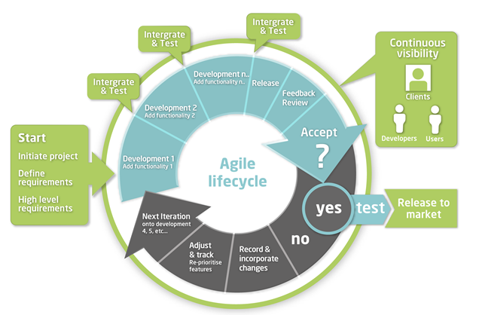

High Level System Architecture

The game, Battlezone Redux, will be programmed in C# through Unity. Unity is a games engine allowing low level access to graphical features available through graphics cards and rendering available in a computer system. This allows for easy implementation of game logic and models using scripts tied to game objects.
Unity has a high level of support for various devices and a large asset store that allows game developers to pay for assets to use in their game. As such, various devices such as the Microsoft Kinect have support through plugins available on the Unity asset store, which makes it easy to implement these devices and focus on programming the game logic instead.
The vector-based graphics used by the original Battlezone are unsupported in native Unity, so a plugin which allows the game engine to draw vector based graphics will be used, which is called Vectrosity. This will be used to render in game objects in a similar fashion to the original arcade game, and provide a similar experience in Unity.

Detailed System Design

0. Use case diagram:

-Player menu use case

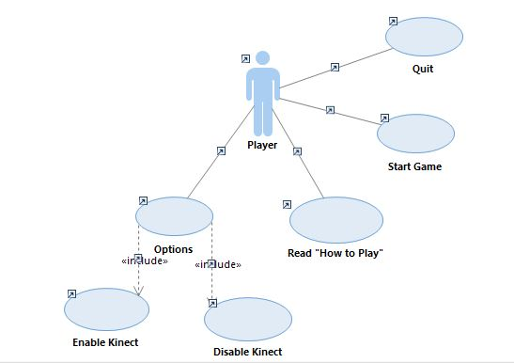

Player In-Game Use Case:

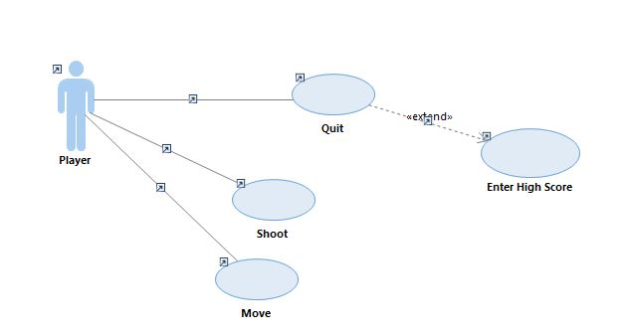

1. Class diagram

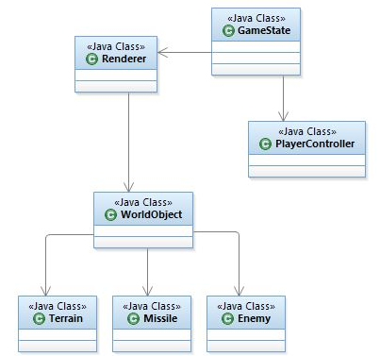

2. Sequence diagram

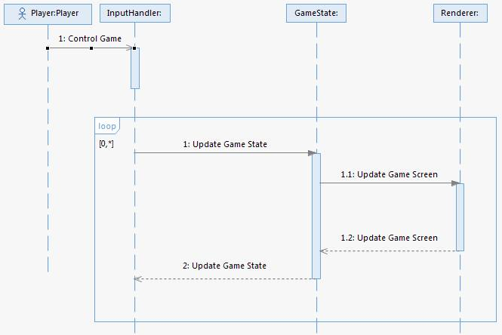

Related Documents
Document Title | Author(s) | Description
e.g. test plan, design document, user manual, test results

